The Project Schedule Management and Performance Report
Student’s Name
Institutional Affiliation

TABLE OF CONTENTS
Part A: The Project Schedule Management Plan 4
Project Scope Definition 4
Schedule Management Plan 4
Scheduling Process 6
Activity Sequence 6
Resource and Project Talent 7
Project Resource Allocation and Project Costs 8
Project Schedule 9
Part B: The Project Performance Report 11
Reference 16

List of Figures
Figure 1: Project Gantt chart 9
Figure 2: Project baseline 10
Figure 3: Project summary 12
Figure 4: Earned Value Report 13
Figure 5: Earned Value cost indicators 14
Figure 6: Earned Value Schedule Indicators 15

Part A: The Project Schedule Management Plan

Project Scope Definition
This project is a celebratory and transformational expedition for all Canadians. It entails a journey aimed at captivating the Canadians’ imagination and more understanding of their country, beauty and vast opportunities in the future. The project is purposed to instill a long-term sense of pride and inspire future Canadians to contribute to their country and the world at large. The project is limited to a 150-day sailing from Toronto to Victoria through the Northwest Passage that connects the Canadians from coast to coast to coast (C3). After the journey, other deliverables include documentaries and videos, books and giant floor maps describing the journey and what was learned. Also, we will create travelling multimedia exhibitions and analyze samples collected during the journey.

Schedule Management Plan
To establish a project schedule, I am planning to adopt the following five steps. The first step involves writing down the project tasks. This step seems obvious, but it is the stage where the project team may forget some activities, and once the project schedule is created, we might forget adding them until we discover they are undone.
As a project manager, I will involve other members in creating tasks. We will begin the list with we what know should be included such as all wider project management activities, then get members together to add to it. Every element of the project will be deeply planned. We will have weekly meetings to reflect on the project scope and allocate some time updating the schedule before finalizing it.
The second step is establishing the order of activities/tasks. This step means what task should be done before the other. In this project, the first task is creating the scope, then identifying partners while the last steps are creating travelling multimedia exhibitions and analyzing samples obtained during the journey.
A Gantt chart graphically represents a project schedule and illustrates the connection between activities. They are called dependencies, and often are marked using black lines. The MS project draws lines to link dependencies if the dependency information is entered; the order of tasks to be done. I intend to work with the team to plan the priority of tasks. At first, the order of tasks will be written on the paper before entering them into the MS project software.
In the third step, we will create the project milestones. Project milestones are points that mark completion of an activity or any important moment on the plan. For instance, a milestone is the end of the task “production of Canada C3 documentaries and videos” in this project. We will put milestones in their appropriate places and connect them to relevant tasks. The aim is making the milestones always appear on the schedule to identify if we are on track in completing tasks within the deadline. A milestone eases project scheduling.
Fourthly, I will calculate the timescale. Once we have tasks, their order of execution and milestones, fixed dates will be added. For instance, a MS project automatically schedules the project to start today, which is against our intentions. Thus, I will use the MS project and navigate through dates to ensure the tasks begin according to our expectations. This can be done by altering the dates manually or adding additional dates. A timescale will also allow reviewing the project duration. An MS project sets the task duration to a default value, which can be as little as one day. In this project, different durations will be allocated to each task depending on their complexity.
Finally, we will have specific people executing specific tasks. Allocating people to tasks is important because if it is unclear who works on a certain task, some project members might underwork at the expense of others. Activities in the Gantt chart will be used to allocate tasks to appropriate members. After a task is assigned, project members will receive a call informing them of the new roles. Also, I will check to ensure no one is overworked or underworked, and if this happens, the order or dates of tasks can be changed to fit periods the resources are available.

Scheduling Process
  - To accurately estimate the project duration, the bottom-up approach was used. This approach entails creating the project estimate as a whole. To analyze from the bottom –up approach, the whole project was split into larger tasks and further to smaller tasks. Then, I estimated the time required to complete each smaller task. This time estimation approach is more accurate because it considers each task incrementally. Finally, the total amount of time required to execute each larger task was added up to estimate the total amount of time needed to complete the whole project.

Activity Sequence
The following are the major milestones in this project:
- Project scope
- Identification of project partners
- Gathering of resources
- Creation of the budget
- Sailing coast to coast to coast and meeting coastal communities
- Production of Canada C3 documentaries and videos
- Canada C3 books
- Production of Canada C3 Maps
- Creation of travelling multimedia exhibitions
- Analysis of samples collected during C3 science program

Resource and Project Talent
The resources required in this project include the scientists, artists, indigenous elders, historians, community leaders, youth, journalists and educators. Also, we need twenty computers and fifteen video cameras. The following are agencies needed in this project:
- Alliance of Natural History Museums of Canada
- Arctic Inspiration Prize
- Communications and Power Industries
- HoneyBar
- Vancouver Maritime Museum
- Assembly of First Nations
- Facebook
- Canadian Museum of Nature
- Samsung
- First Air and
- Higher Me

Project Resource Allocation and Project Costs
- Youth and artists- To create art and music
- Indigenous elders and community leaders – To connect with coastal communities and cultural issues
- Historians, scientists and educators- To provide history of Canadian coastal communities and analyze samples collected during Canada C3 program. Also, to create travelling multimedia exhibitions and help in the production of C3 book and maps
- Journalists- To capture videos and prepare documentaries of the Canada C3 program
The baseline cost for this project is $2,196,000, which rises largely from sailing coast to coast to coast and closing activities (production of documentaries and videos, books, maps, creation of travelling multimedia exhibitions and analyzing samples).

Project Schedule
- Figure 1: Project Gantt chart
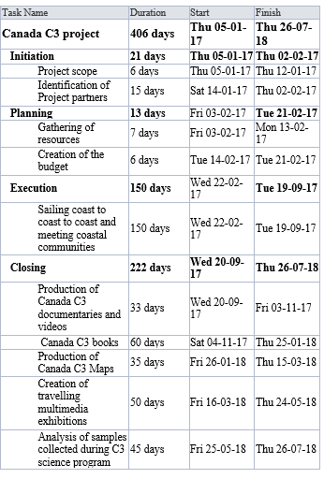

Figure 2: Project baseline
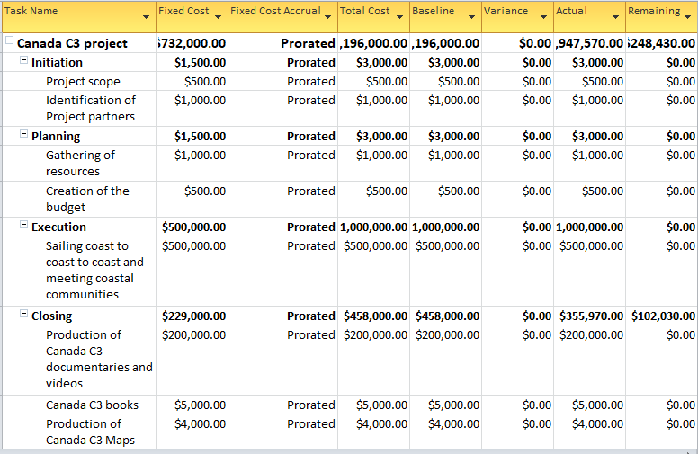

Part B: The Project Performance Report
The earned value (EV) includes a time variable in measuring progress (Larson, 2018). The EV bridges the gap by seeking to answer "looking at the way the project progresses, is the company getting value for money." Some of the equations used by EVA include cost and schedule variance, cost performance indicator, estimated cost at completion and estimated time at completion.
So far, the milestones under initiation, planning and execution are 100% complete. However, Closing is 63% complete. Under the last phase of project management closing, the tasks production of documentaries, books and maps are 100% complete. Creation of travelling multimedia exhibitions is 27% complete while analysis of samples is completely undone. As a result, we are 80% into the project as shown in Figure 3. Figure 4 shows the earned value report, while Figure 5 and Figure 6 show earned value cost indicators and earned value schedule indicators respectively.

Figure 3: Project summary
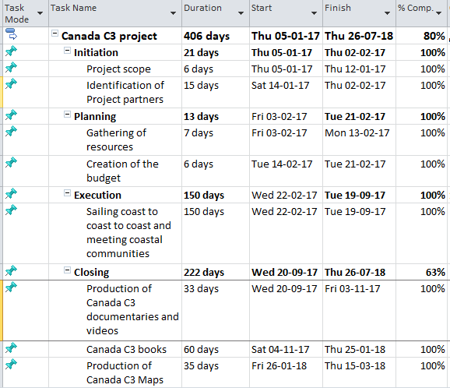

Figure 4: Earned Value Report
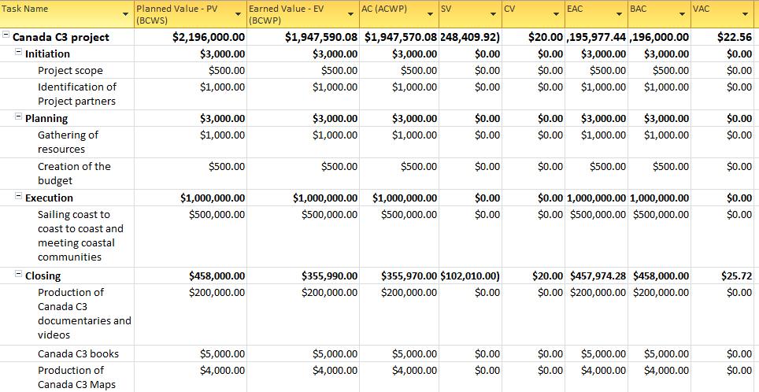

Figure 5: Earned Value cost indicators
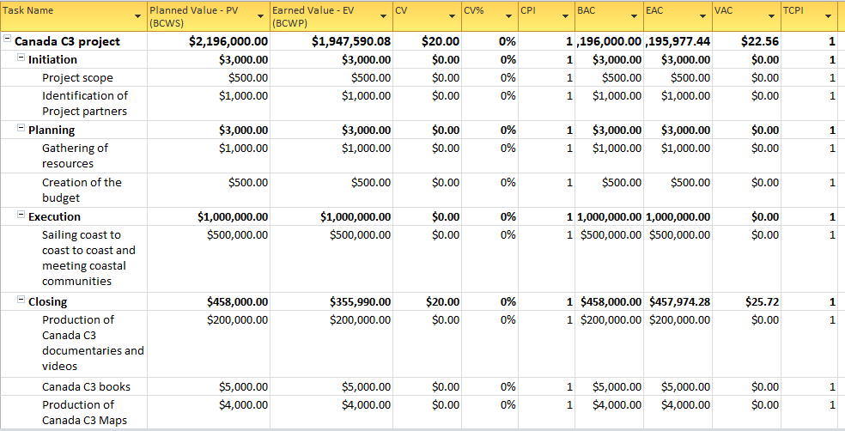

Figure 6: Earned Value Schedule Indicators
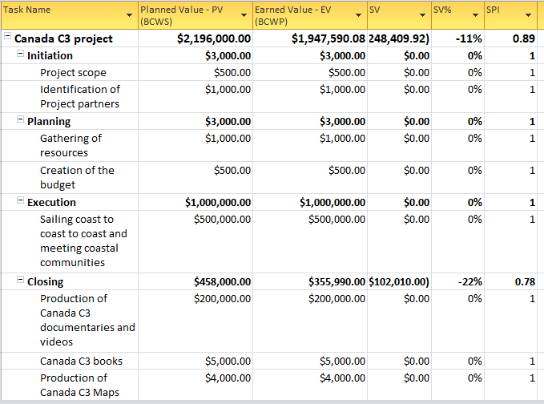

Reference
Larson, E. (2018). Project management: The managerial process, 7th edition. New York: McGraw-Hill Higher Education.

